Fixed calibration to add noise added to training data:
Even/odd indices this is what I got. Before looking at standard error as a function of N.
N= 100,
N_theta = 500
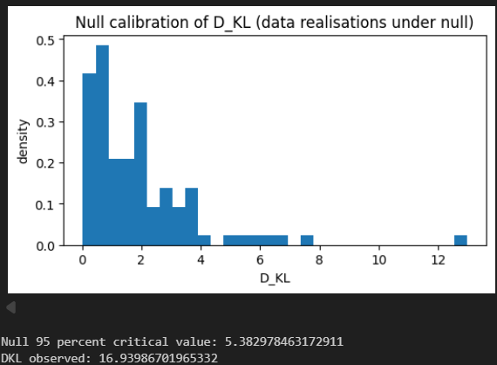

N=200, N_theta =2500
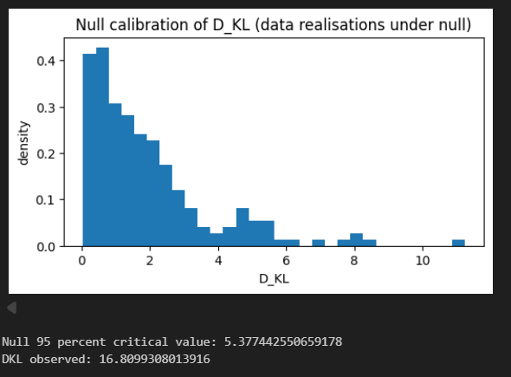

Plotted mean and std dev and error vs N_theta

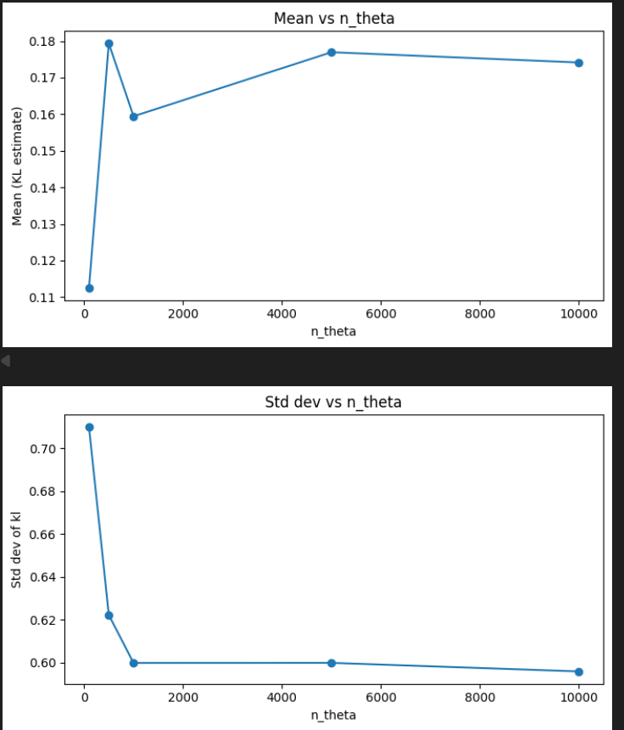
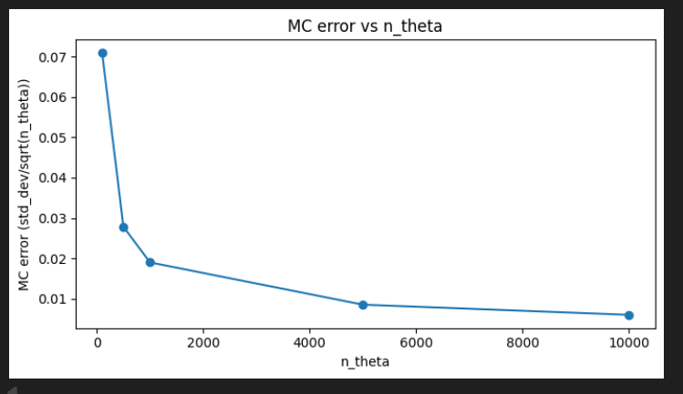

Same graphs on a Log scale:
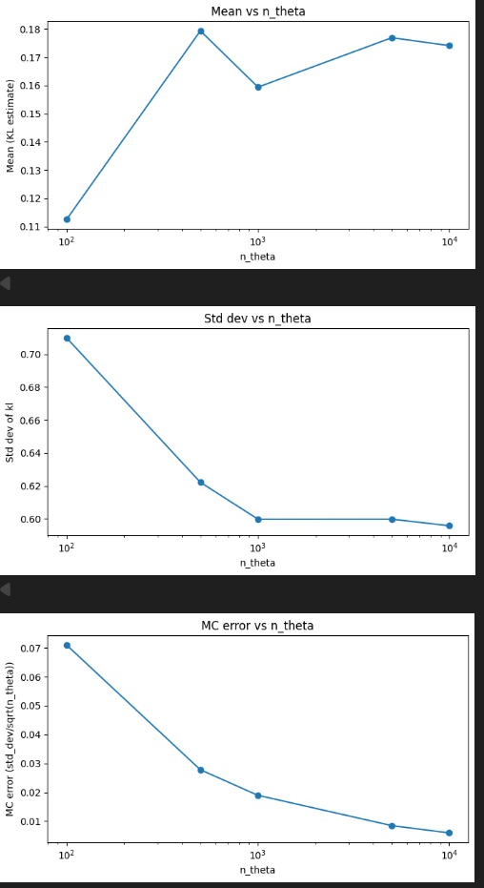
Next check (compare back to page 1): added a systematic to one data split then calibrated, to see if systematic detected in calibration. Chosen systematic: increase lynx pop by 5 percent, decrease hare by 5 percent. Result:
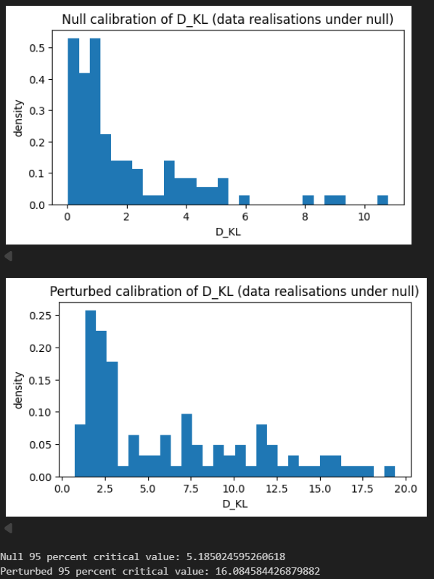
In hindsight quite a big perturbation, so try smaller
0.5% increase in lynx pop in split 1: led to barely noticeable difference.
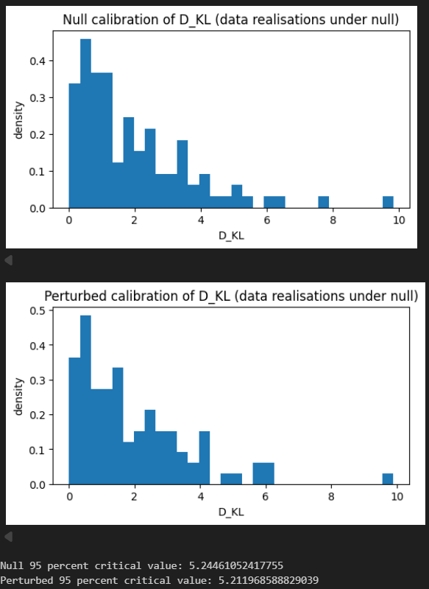

3% increase in lynx pop: clearly detected led to increase in crit val and flattening of peak
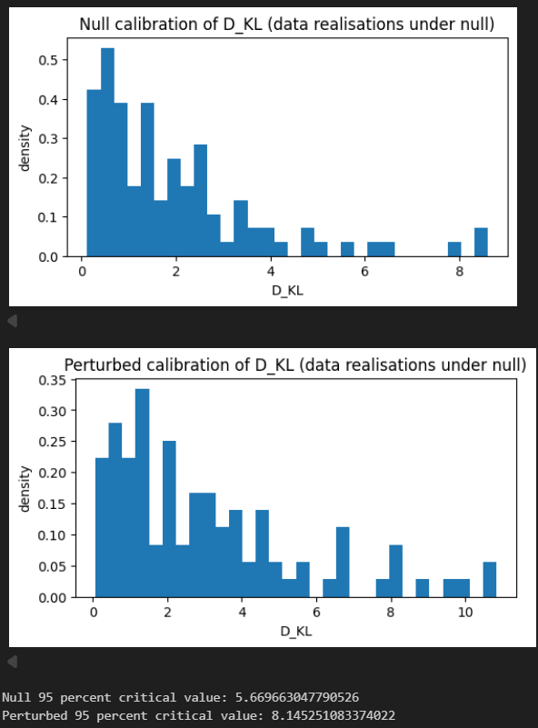

29/01
LV Changes – added noise to x_observed, moved to logn prior

FIRST_SECOND SPLIT (wasn’t working last week)
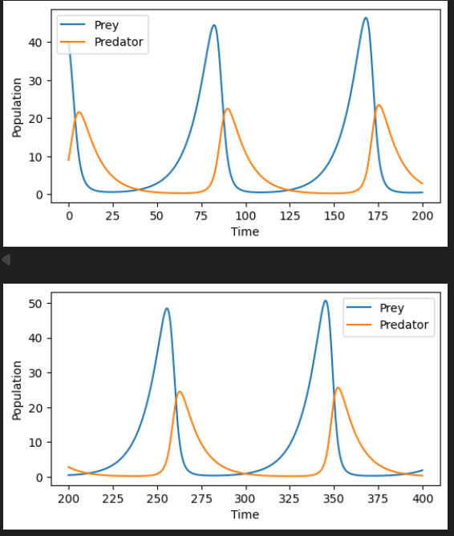
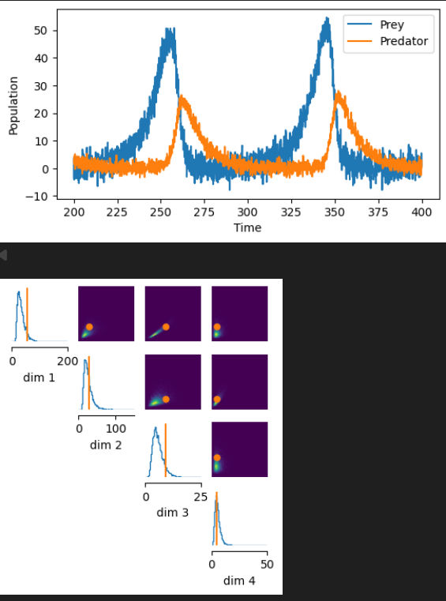
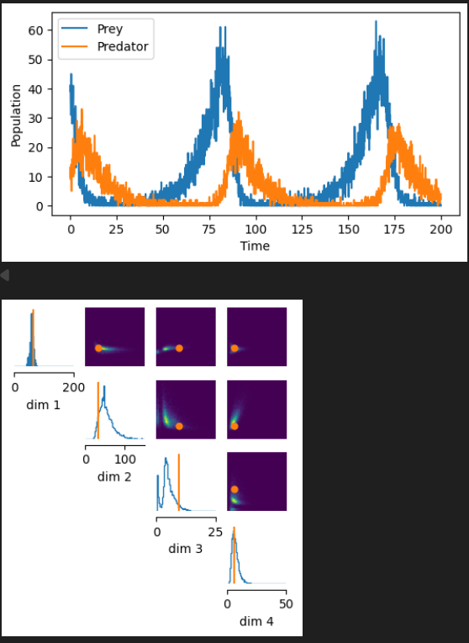
split 1 and split 2 noisy x_obs plus prior predictive checks – performing better, need to shift dim3

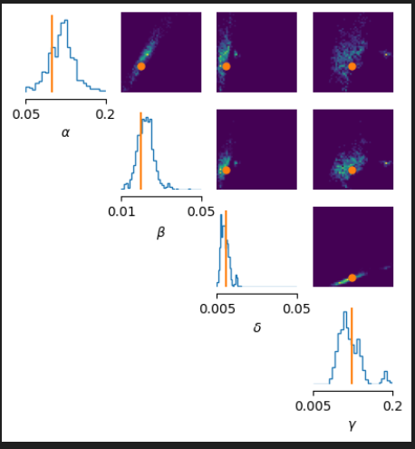
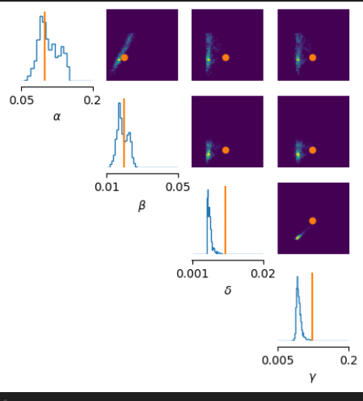
BEFORE CHANGES VS. AFTER:
Note: stopping after only 150 epochs of training just for speed while trying things out, but clear improvement.

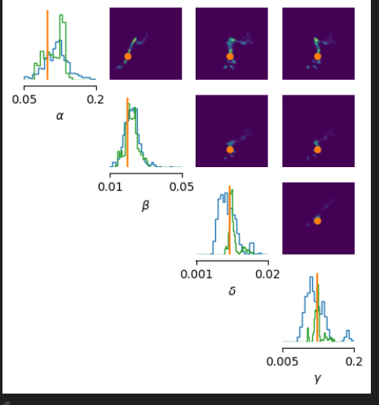
Plotting posteriors together:
KL Calibration and Calculation:
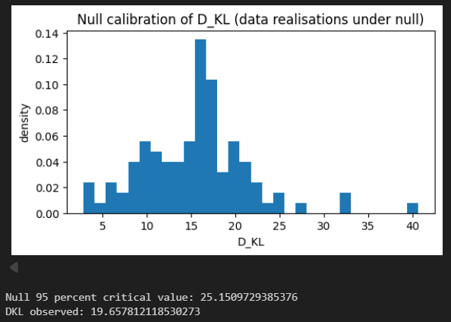

Now look at adding 3% lynx perturbation and see how this is realised in KL. Interestingly, test is not sensitive compared to last weeks result.
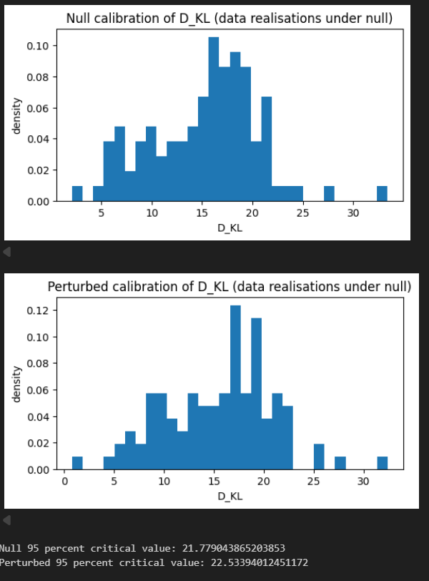

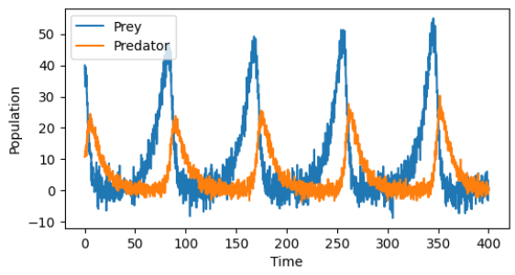
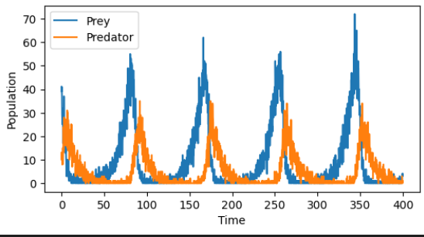
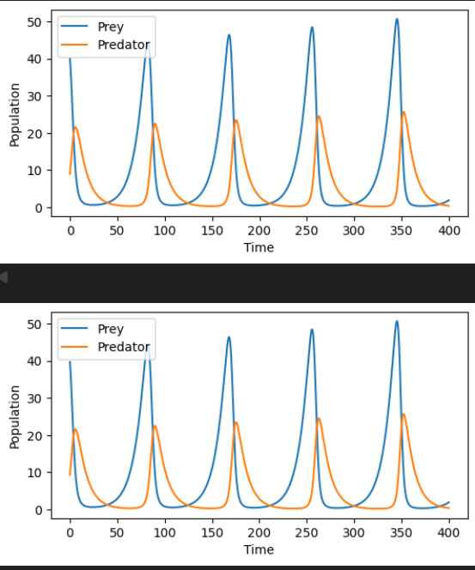
Now do the same with first/second split so we can compare how the posteriors overlay and the ‘typical KL values we get’. Also want to look at effect of 3% lynx perturb.

Note: add less noise, as we have negative values unphysical ?? How to enforce this as at population 0, you wipe out, so do we have to decrease noise as population lowers? Maybe realistic?

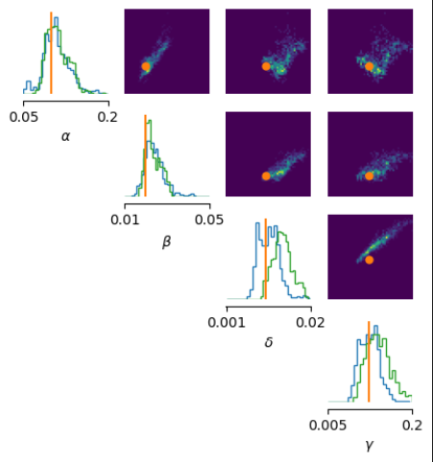
Posteriors plotted on same axes:

Training seems better , again note 150 epochs only.

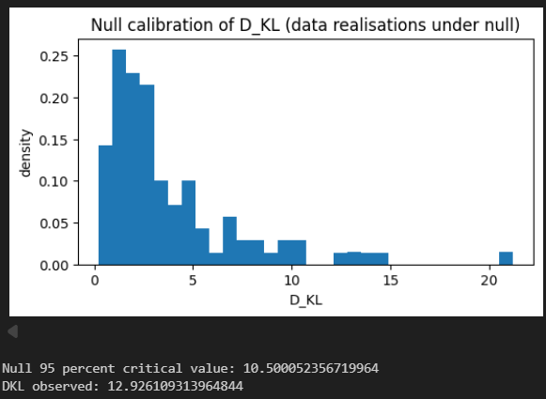
KL Calibration and Calc:
Good that this is lower than we see for splitting first second. See side by side also below



even/odd above, first second below

Now look at adding the perturbation:
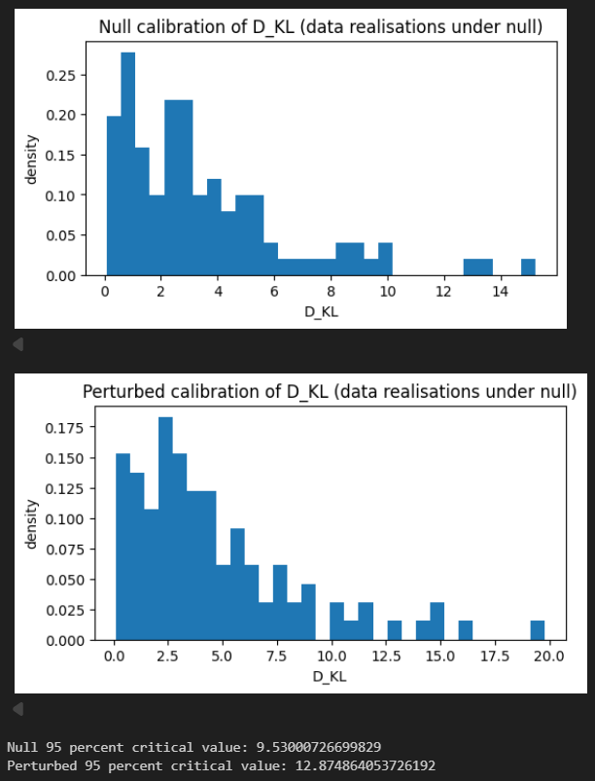
See a higher sensitivity to perturbation, likely due to higher initial closeness of splits

05/02
Gaussian Model:
Prior: theta_i ~ N(1,2), independent
Likelihood: f(x_i|theta_i) = N(theta_i + loc, scale)
Process: generate $θ_{i}$, i =1,..N, and plug into simulator 1 with loc1, scale1 then into simulator 2 with loc2, scale 2. Train each split and compare. Generate one theta_obs, put in sim_i x_obs_i,
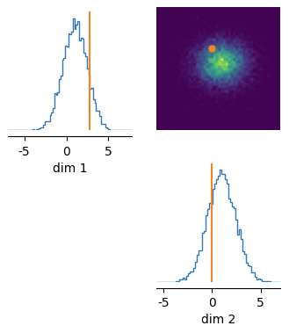
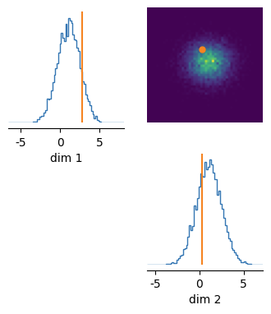
Prior Predictive Checks split 1(left) and split2 (right):
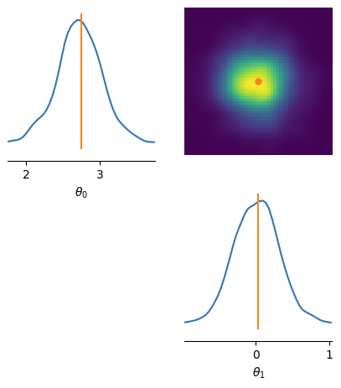
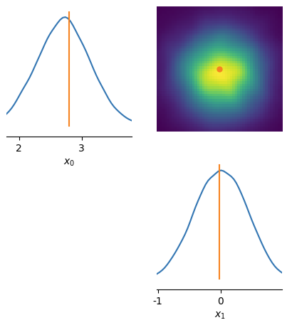
After training (showing only split 2 but similar for split 1). This shows inference for parameter and simulated draws from parameters, compared to obs:
Comparing to analytical posterior (Split 1 and 2): here I just plotted marginals
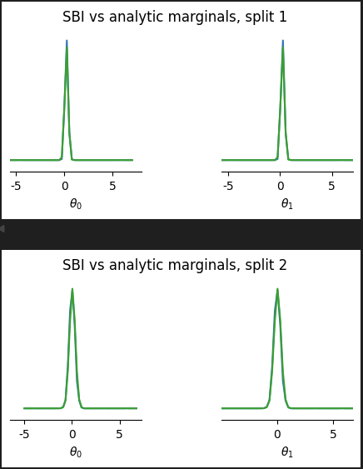

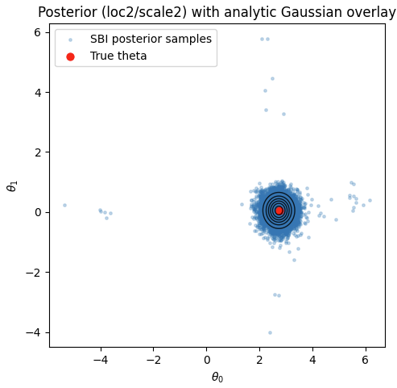
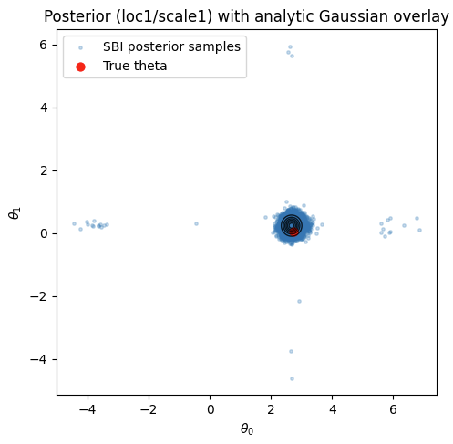
Next graoh is gpt generated, but shows 2d overlay of posterior:

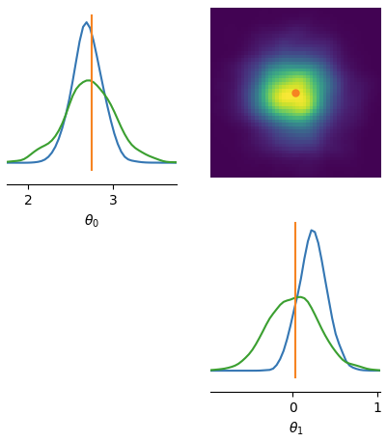
SBI Posteriors overlayed (and smoothed):
KL Calculation:
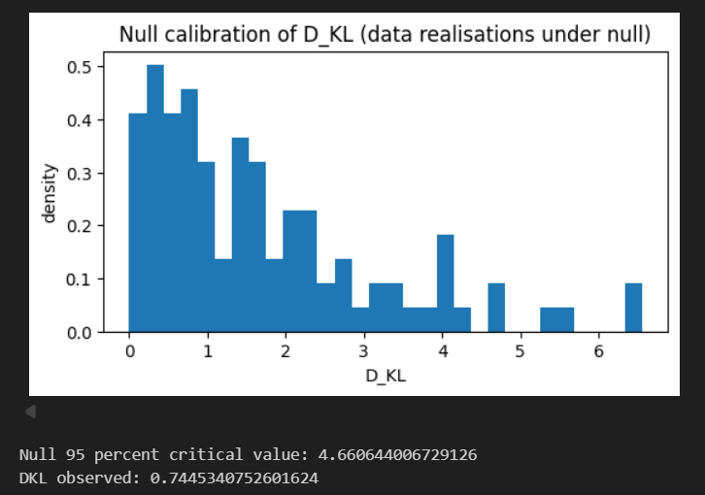

Error:
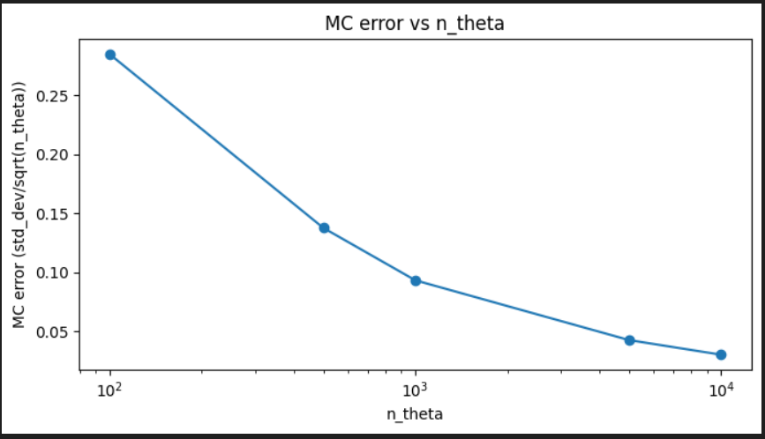

Adding a perturbation. As we can’t differentiate splitting by odd/even first second as draws indpt, tried adding different perturbations to see sensitivity:

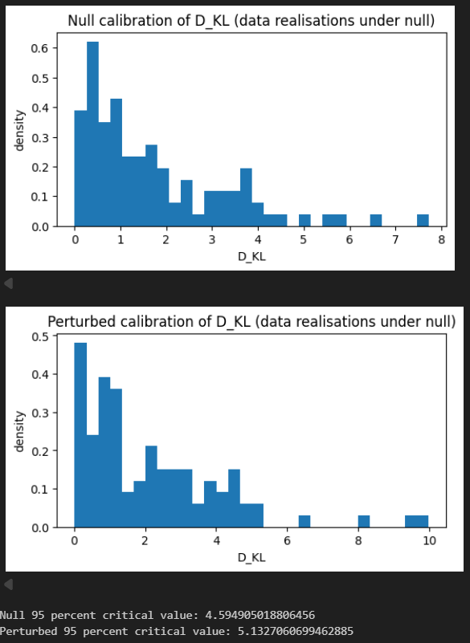
Shifted mean by 0.1: no/small change in crit val:
x
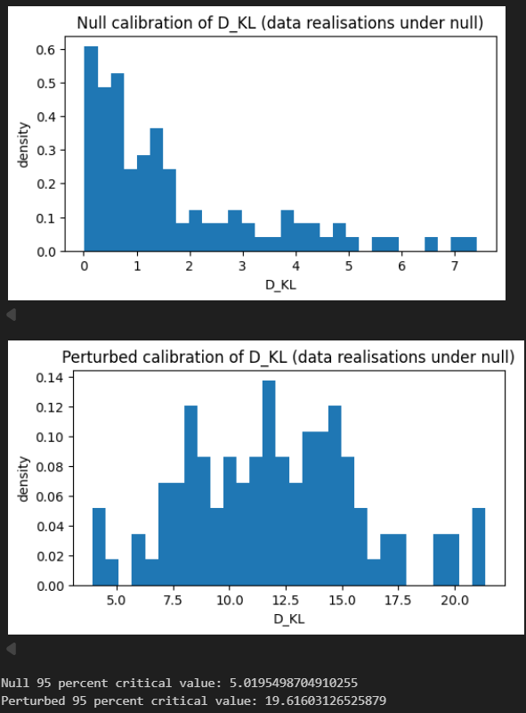
Now shifted mean by 0.7: leads to large shift in KL

Question: need a method to say what shift in crit val is enough to deem significant? –.
Q: what is a sensible way of choosing a crit val, as im using 95 percentile but are there better choices?

This graph: incorrect but interesting, was kl calibrated for a splti with noise 1 and a split with noise 2. Interesting as shows sensitivity, tpical kl val way higher than when done correclty
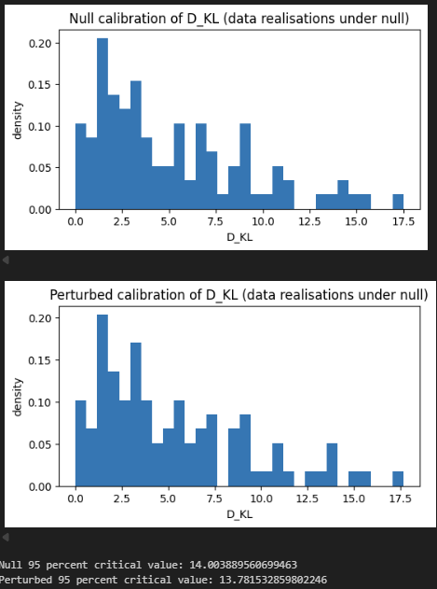

Changes to LV
Adjusted prior weights, and trained for 1000 epochs.
hard to adjust precisely as considering summaries, but changing one param changes all four -> tried some sensitivity matrix thing.
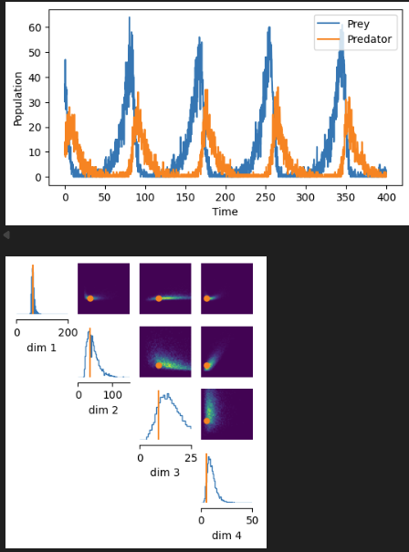
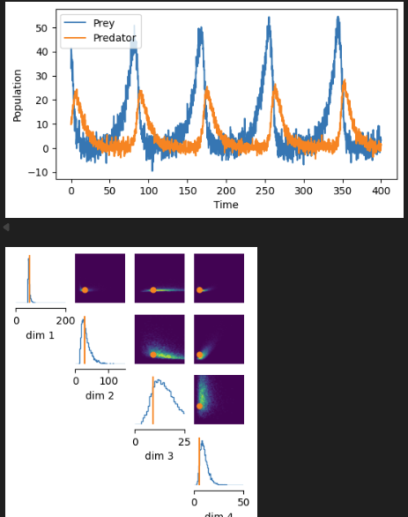
New prior predictive checks below:

vs OLD PRIORS:
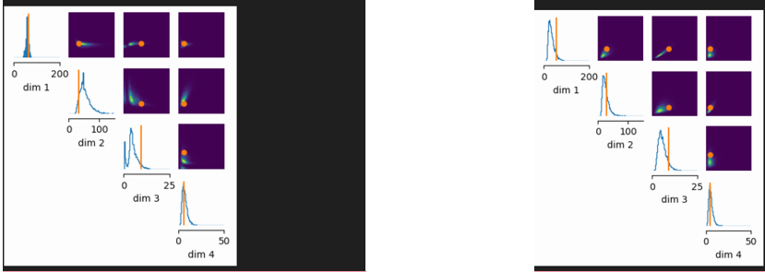

Posterior after training – looking at first/second split (ran till convergence):
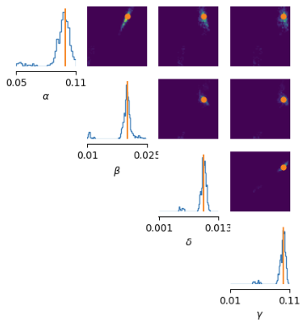
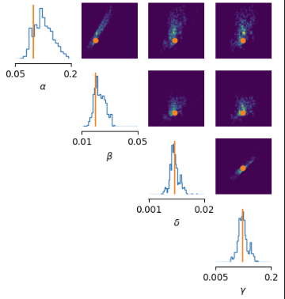
KL etc. now working same as last week, models just trained better

Specific Tests
Add off diagonal elements to the gaussian case:
Prior: $θ∼N\left(\left(\begin{matrix}1 \\ 1\end{matrix}\right), \left(\begin{matrix}2 & 0 \\ 0 & 2\end{matrix}\right)\right)$,

Split 1 Likelihood: $N\left(\left(\begin{matrix}θ_{1}+loc \\ θ_{2}+loc\end{matrix}\right), \left(\begin{matrix}scale & 0 \\ 0 & scale\end{matrix}\right)\right)$

Split 2 Likelihood: $N\left(\left(\begin{matrix}θ_{1}+loc \\ θ_{2}+loc\end{matrix}\right), \left(\begin{matrix}scale & eps \\ eps & scale\end{matrix}\right)\right)$, set eps = 0.05 in first case

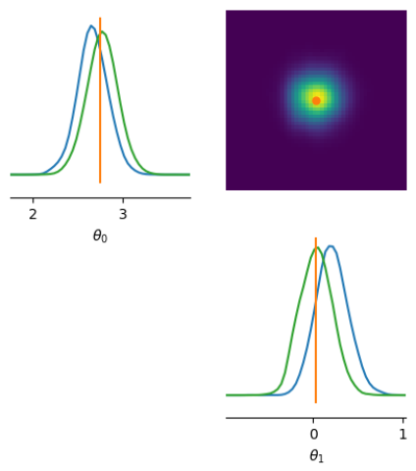

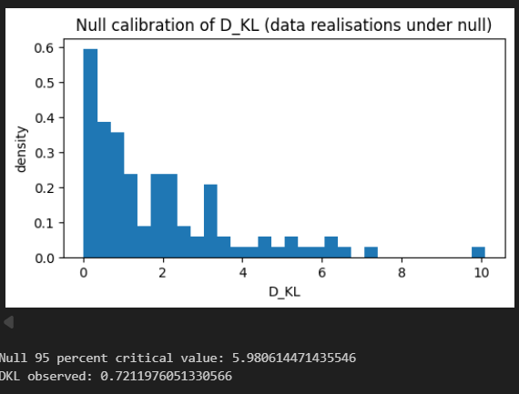
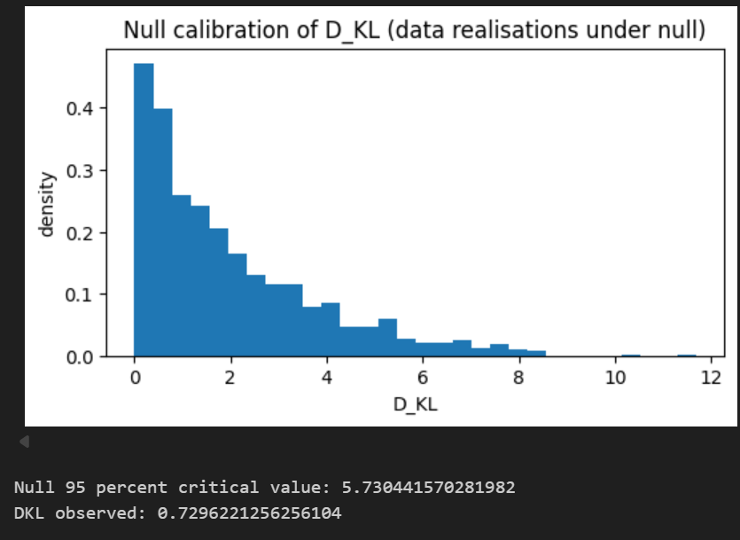
Comparing typical kl values to typical values with a small correlation added:
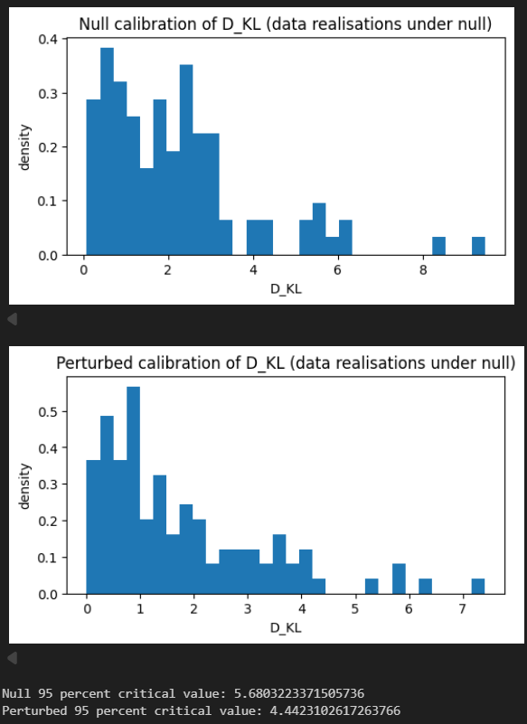
Crit value decreases: would we expect this as we now have correlation?

